Imagine… Express… Create…
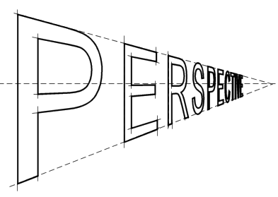
Exploring Art: An After School Art Class

We are just finishing up a great series on building creativity. It has been so much fun seeing what they come up with for their projects.

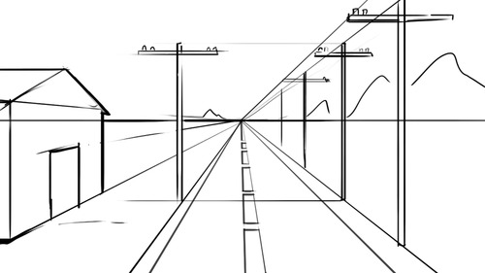
Next up is a much more technical series. We will be learning perspective. Perspective is used to help show distance. We will start with one-point perspective. Then we’ll move onto two-point. Depending on the progress of the group we may venture in to three-point and elliptical perspective.

If you are interested in taking this class, there is an enclosed form that can be filled out and returned to the school office.

Please feel free to contact me with any questions.
Audrey Waid
814-967-3718
sawaid@windstream.net
www.artwithmsaudrey.com

Art with Ms. Audrey
November/December 2015
Art Enrichment: After School Art Class

November and December Session (Nov. 2, 9, 16, 23, Dec. 7, 14)
Grades 5-12
Mondays from 3-4:30
Tuition, including supplies and a simple snack for this 6 week class, is $60.

If you are interested in taking this 6 week session of After School Art Classes please sign and return the form below.
Student Name __________________________________ Grade/age _____________
Phone ____________________________ Email __________________________________
Emergency Contact (during class- Mondays 3-4:30)
________________________________ __________________________________
Additional Information you would like me to be aware of (allergies/medical conditions, etc.)
__________________________________________________________________________________________________________________________________________________________________________________________________________________________________________

Parent/Guardian signature _______________________________ Date ___________________
Print _______________________________
Sometimes I use photographs of student work for promotional purposes. I will not use student names or faces. For printed material I may sometimes use an initial and age (ex. E age 16). If you prefer I not use any photographs of your student’s work I will not but if I have your permission please initial._____

