Imagine… Express… Create…
Exploring Art: An After School Art Class
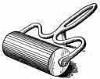
Introduction to Printmaking: overall process and an in-depth look at the art medium known as “printmaking.” More specifically we will highlight block printing.

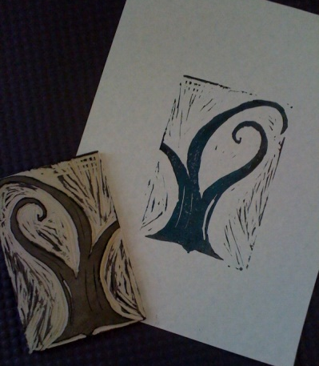
Printmaking is the process of transferring an image onto another surface, usually paper. In block printing the negative space (background) is removed. Ink is added with a brayer to the raised image. We will ease into the full process of printmaking. Then we’ll build on that knowledge and move onto more detailed printmaking skills.

I hope that you can join us learning this unique art technique. If you are interested in taking this class, there is an enclosed form that can be filled out and returned to the school office.

Please feel free to contact me with any questions.
Audrey Waid
814-967-3718
sawaid@windstream.net
www.artwithmsaudrey.com
Art with Ms. Audrey
January/February 2016
Art Enrichment: After School Art Class

January and February Session (Jan. 11, 25, Feb. 1, 8, 22, 29)
Grades 5-12
Mondays from 3-4:30
Tuition, including supplies and a simple snack for this 6 week class, is $60.

If you are interested in taking this 6 week session of After School Art Classes please sign and return the form below.
Student Name __________________________________ Grade/age _____________
Phone ____________________________ Email __________________________________
Emergency Contact (during class- Mondays 3-4:30)
________________________________ __________________________________
Additional Information you would like me to be aware of (allergies/medical conditions, etc.)
__________________________________________________________________________________________________________________________________________________________________________________________________________________________________________

Parent/Guardian signature _______________________________ Date ___________________
Print _______________________________
_____ Yes- Permission to photograph student work (never faces or names) for promotional purposes. Students also have the option to let me know if they do not want a specific piece photographed.
_____ No- I would rather student work not be photographed.

