Imagine… Express… Create…
Exploring Art: An After School Art Class

Drawing Series: Artists tend to look at the world around them in a different way. In this series we will be learning to see. We will learn to see as an artist sees.
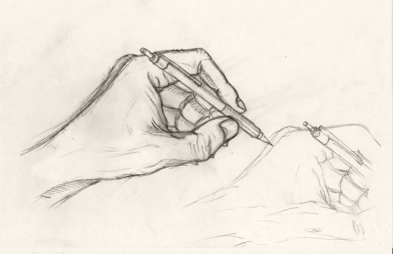
Being able to draw what you see is a fundamental artist skill. Observational drawing trains your brain to think differently. By learning to notice lines and values, anyone is able to accurately recreate an image. We will do several exercises that train the brain to start to see as an artist. But most importantly we will practice, practice, practice with lots of drawing from real life. Guided instruction will help improve any level of drawing skills so that students are well on their way to drawing anything they see.

I hope that you can join us for this observational drawing series. If you are interested in taking this class, there is an enclosed form that can be filled out and returned to the school office.

Please feel free to contact me with any questions. www.artwithmsaudrey.com
Audrey Waid
814-967-3718
sawaid@windstream.net

Art with Ms. Audrey
March/April 2016
Art Enrichment: After School Art Class

March and April Session (March 7, 14, April 4, 11, 18, 25)
Grades 5-12
Mondays from 3-4:30
Tuition, including supplies and a simple snack for this 6 week class, is $60.

If you are interested in taking this 6 week session of After School Art Classes please sign and return the form below.
Student Name __________________________________ Grade/age _____________
Phone ____________________________ Email __________________________________
Emergency Contact (during class- Mondays 3-4:30)
________________________________ __________________________________
Additional Information you would like me to be aware of (allergies/medical conditions, etc.)
__________________________________________________________________________________________________________________________________________________________________________________________________________________________________________
Parent/Guardian signature _______________________________ Date ___________________
Print _______________________________
_____ Yes- Permission to photograph student work (never faces or names) for promotional purposes. Students can also let me know if they do not want a specific piece photographed.
_____ No- I would rather student work not be photographed.

