Outline one repeating pattern in each.

[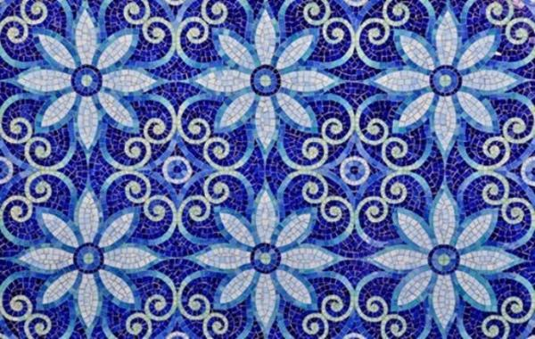](http://www.google.com/url?sa=i&rct=j&q=&esrc=s&source=images&cd=&cad=rja&uact=8&ved=0ahUKEwjPoOS9jcPKAhUEGz4KHUt8AUEQjRwIBw&url=http://www.lushome.com/modern-wall-tile-designs-white-blue-colors-inspired-famous-delfware/113706&psig=AFQjCNF58bXkOefFN8BOCpyVgXALrL2KvA&ust=1453747354852561)

[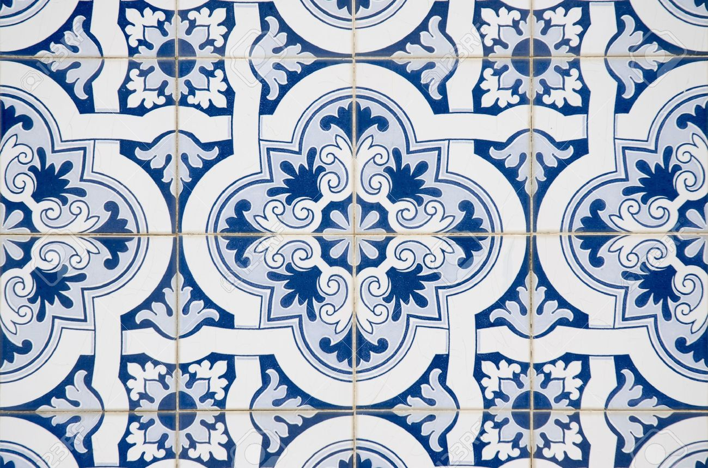](http://www.google.com/url?sa=i&rct=j&q=&esrc=s&source=images&cd=&cad=rja&uact=8&ved=0ahUKEwjk9pmkjcPKAhXKbj4KHYo3BEoQjRwIBw&url=http://www.123rf.com/photo_11326105_backgrounds-and-textures-intricate-ceramic-tile-design.html&psig=AFQjCNF58bXkOefFN8BOCpyVgXALrL2KvA&ust=1453747354852561)

Copy one section of tile in black and white design.

[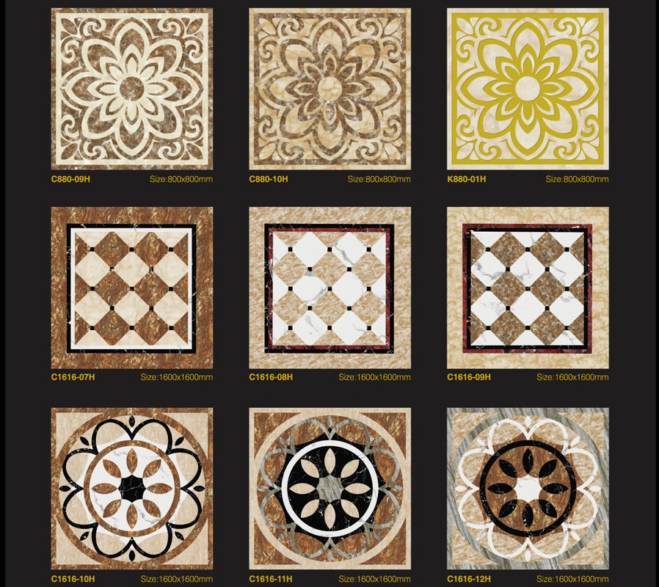](http://www.google.com/url?sa=i&rct=j&q=&esrc=s&source=images&cd=&cad=rja&uact=8&ved=0ahUKEwj1neqIjcPKAhWCcT4KHSMgByoQjRwIBw&url=http://fsoceanland.en.made-in-china.com/product/HXmQWIVYOfcb/China-30X30-Big-Project-Polished-Porcelain-Floor-Tile-Design-C880-09H-.html&psig=AFQjCNF58bXkOefFN8BOCpyVgXALrL2KvA&ust=1453747354852561)

[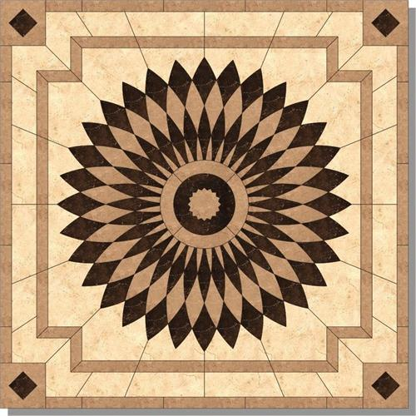](http://www.google.com/url?sa=i&rct=j&q=&esrc=s&source=images&cd=&cad=rja&uact=8&ved=0ahUKEwjvpeWSjMPKAhWBNz4KHV1qCtcQjRwIBw&url=http://www.homeportfolio.com/listing/monticello_tile_design.html&psig=AFQjCNFzvK8HP79EWUj-kD8cQ6Swiqgzbw&ust=1453747106261402)